Shepard Fairey: Lesson On Shading
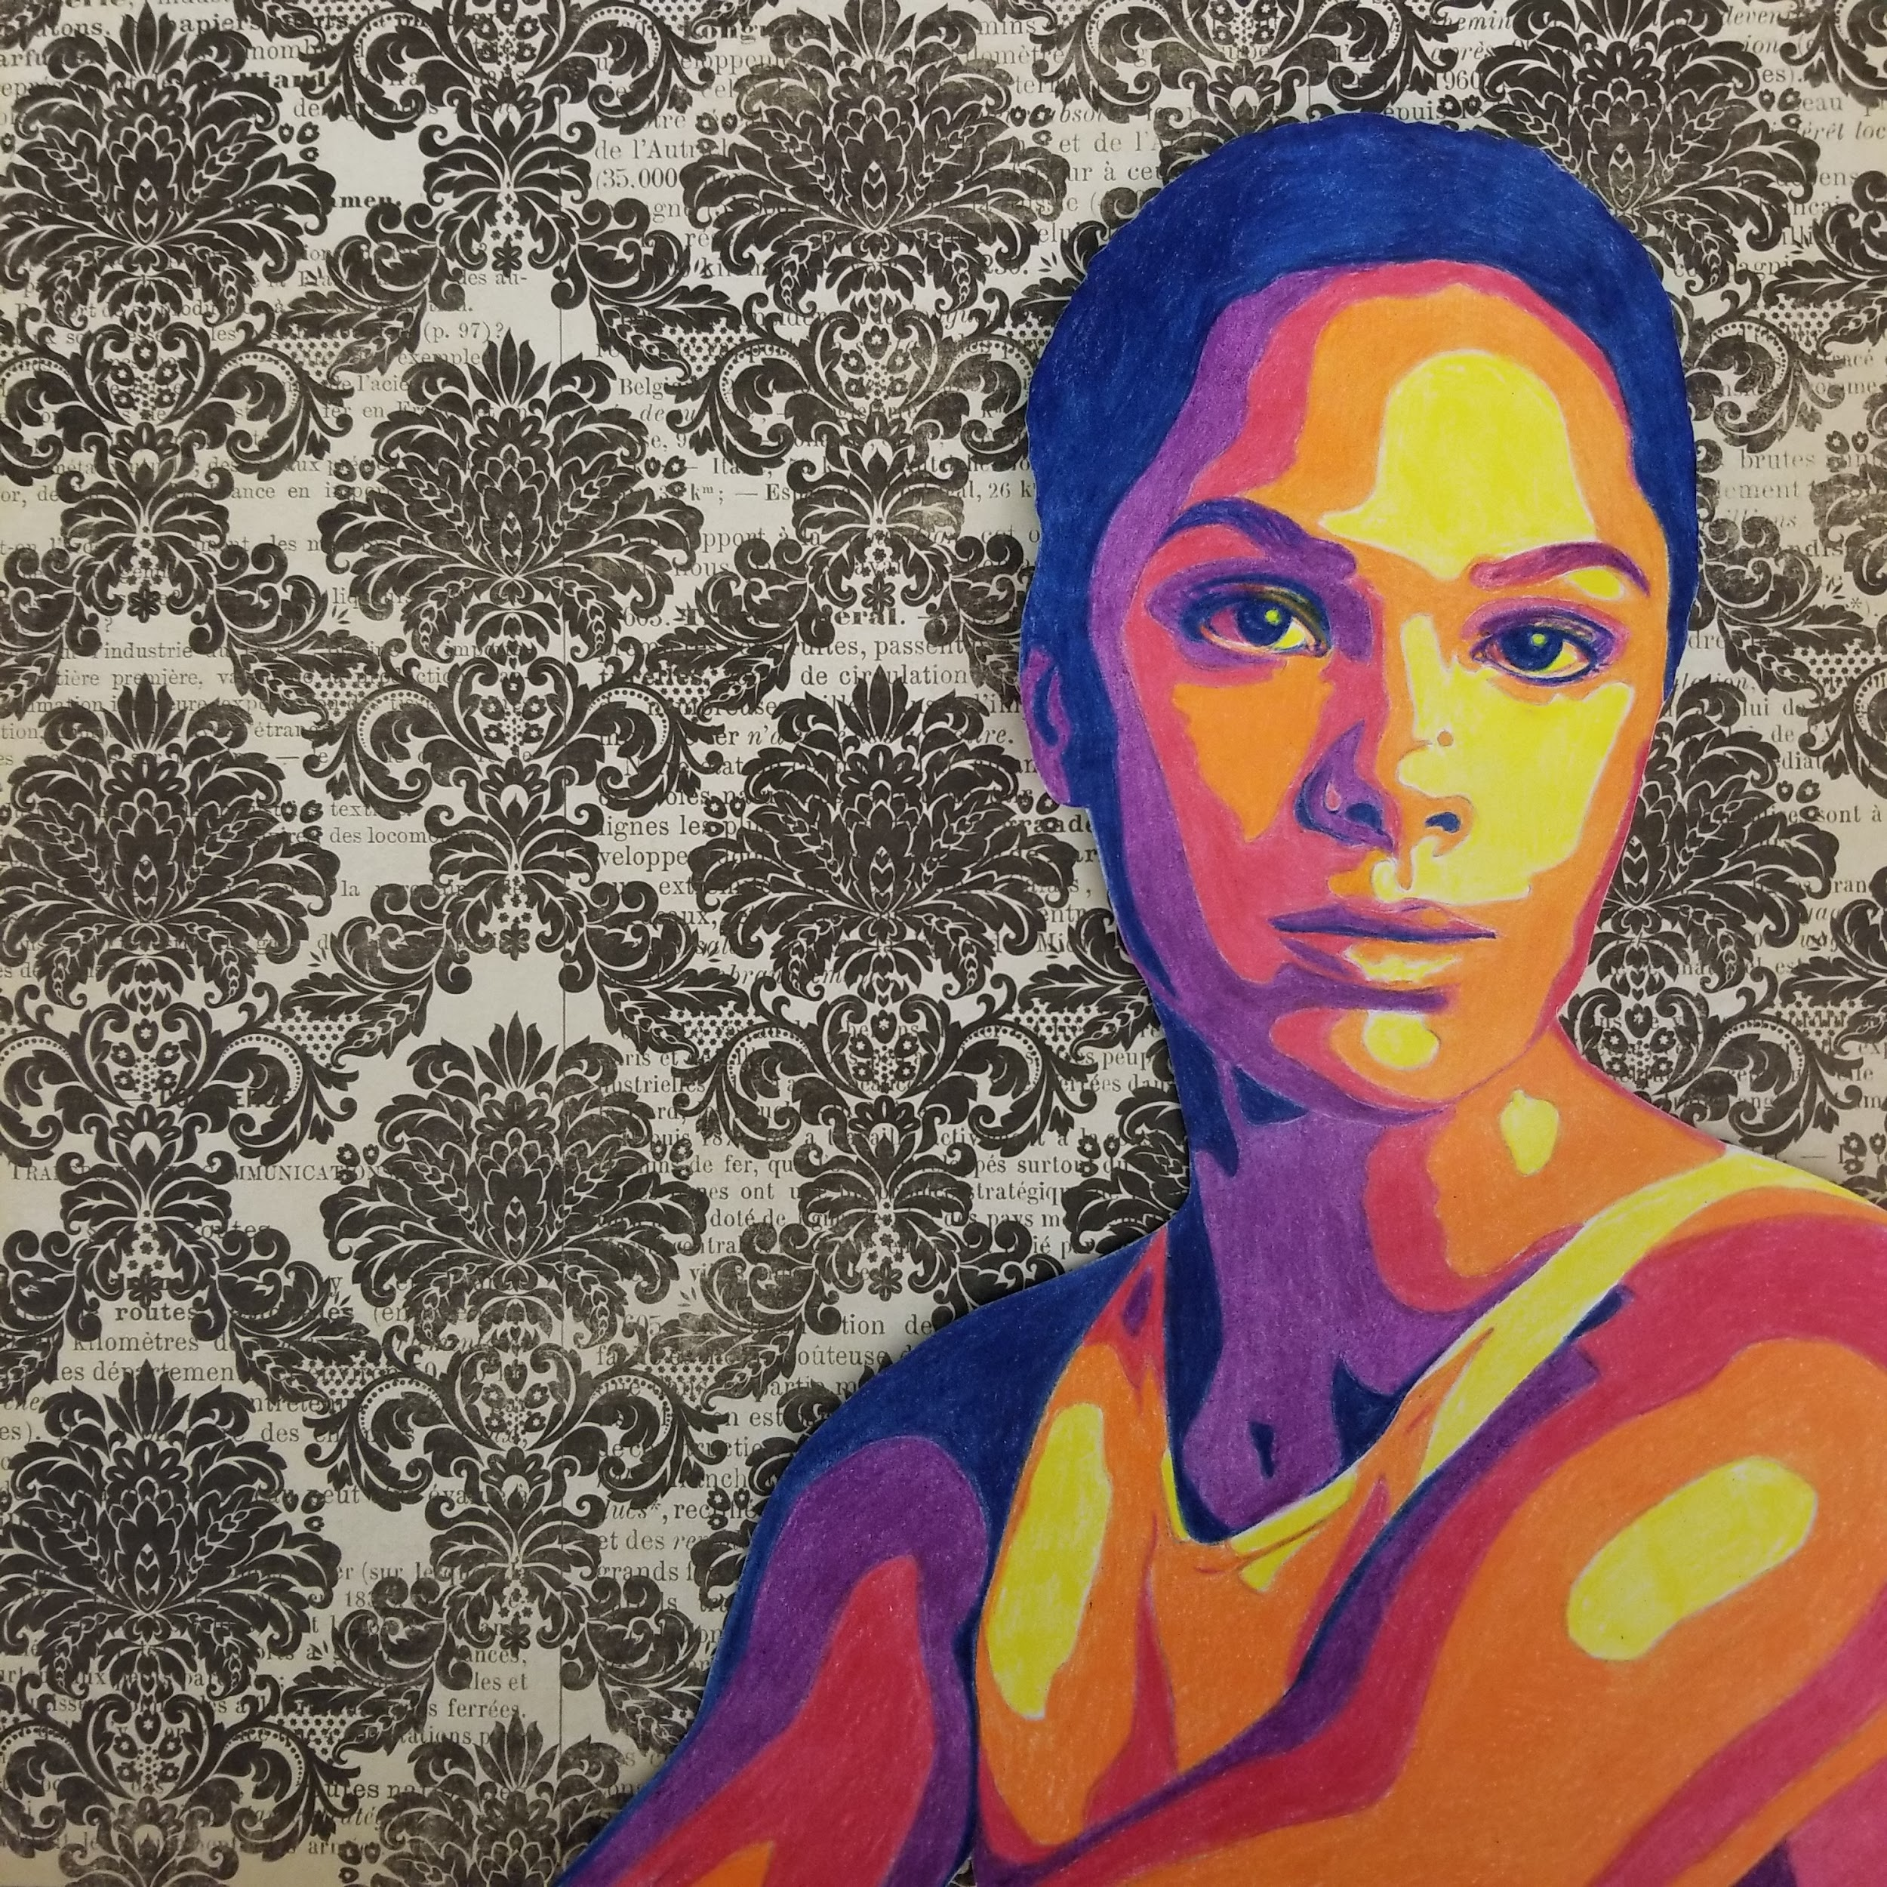
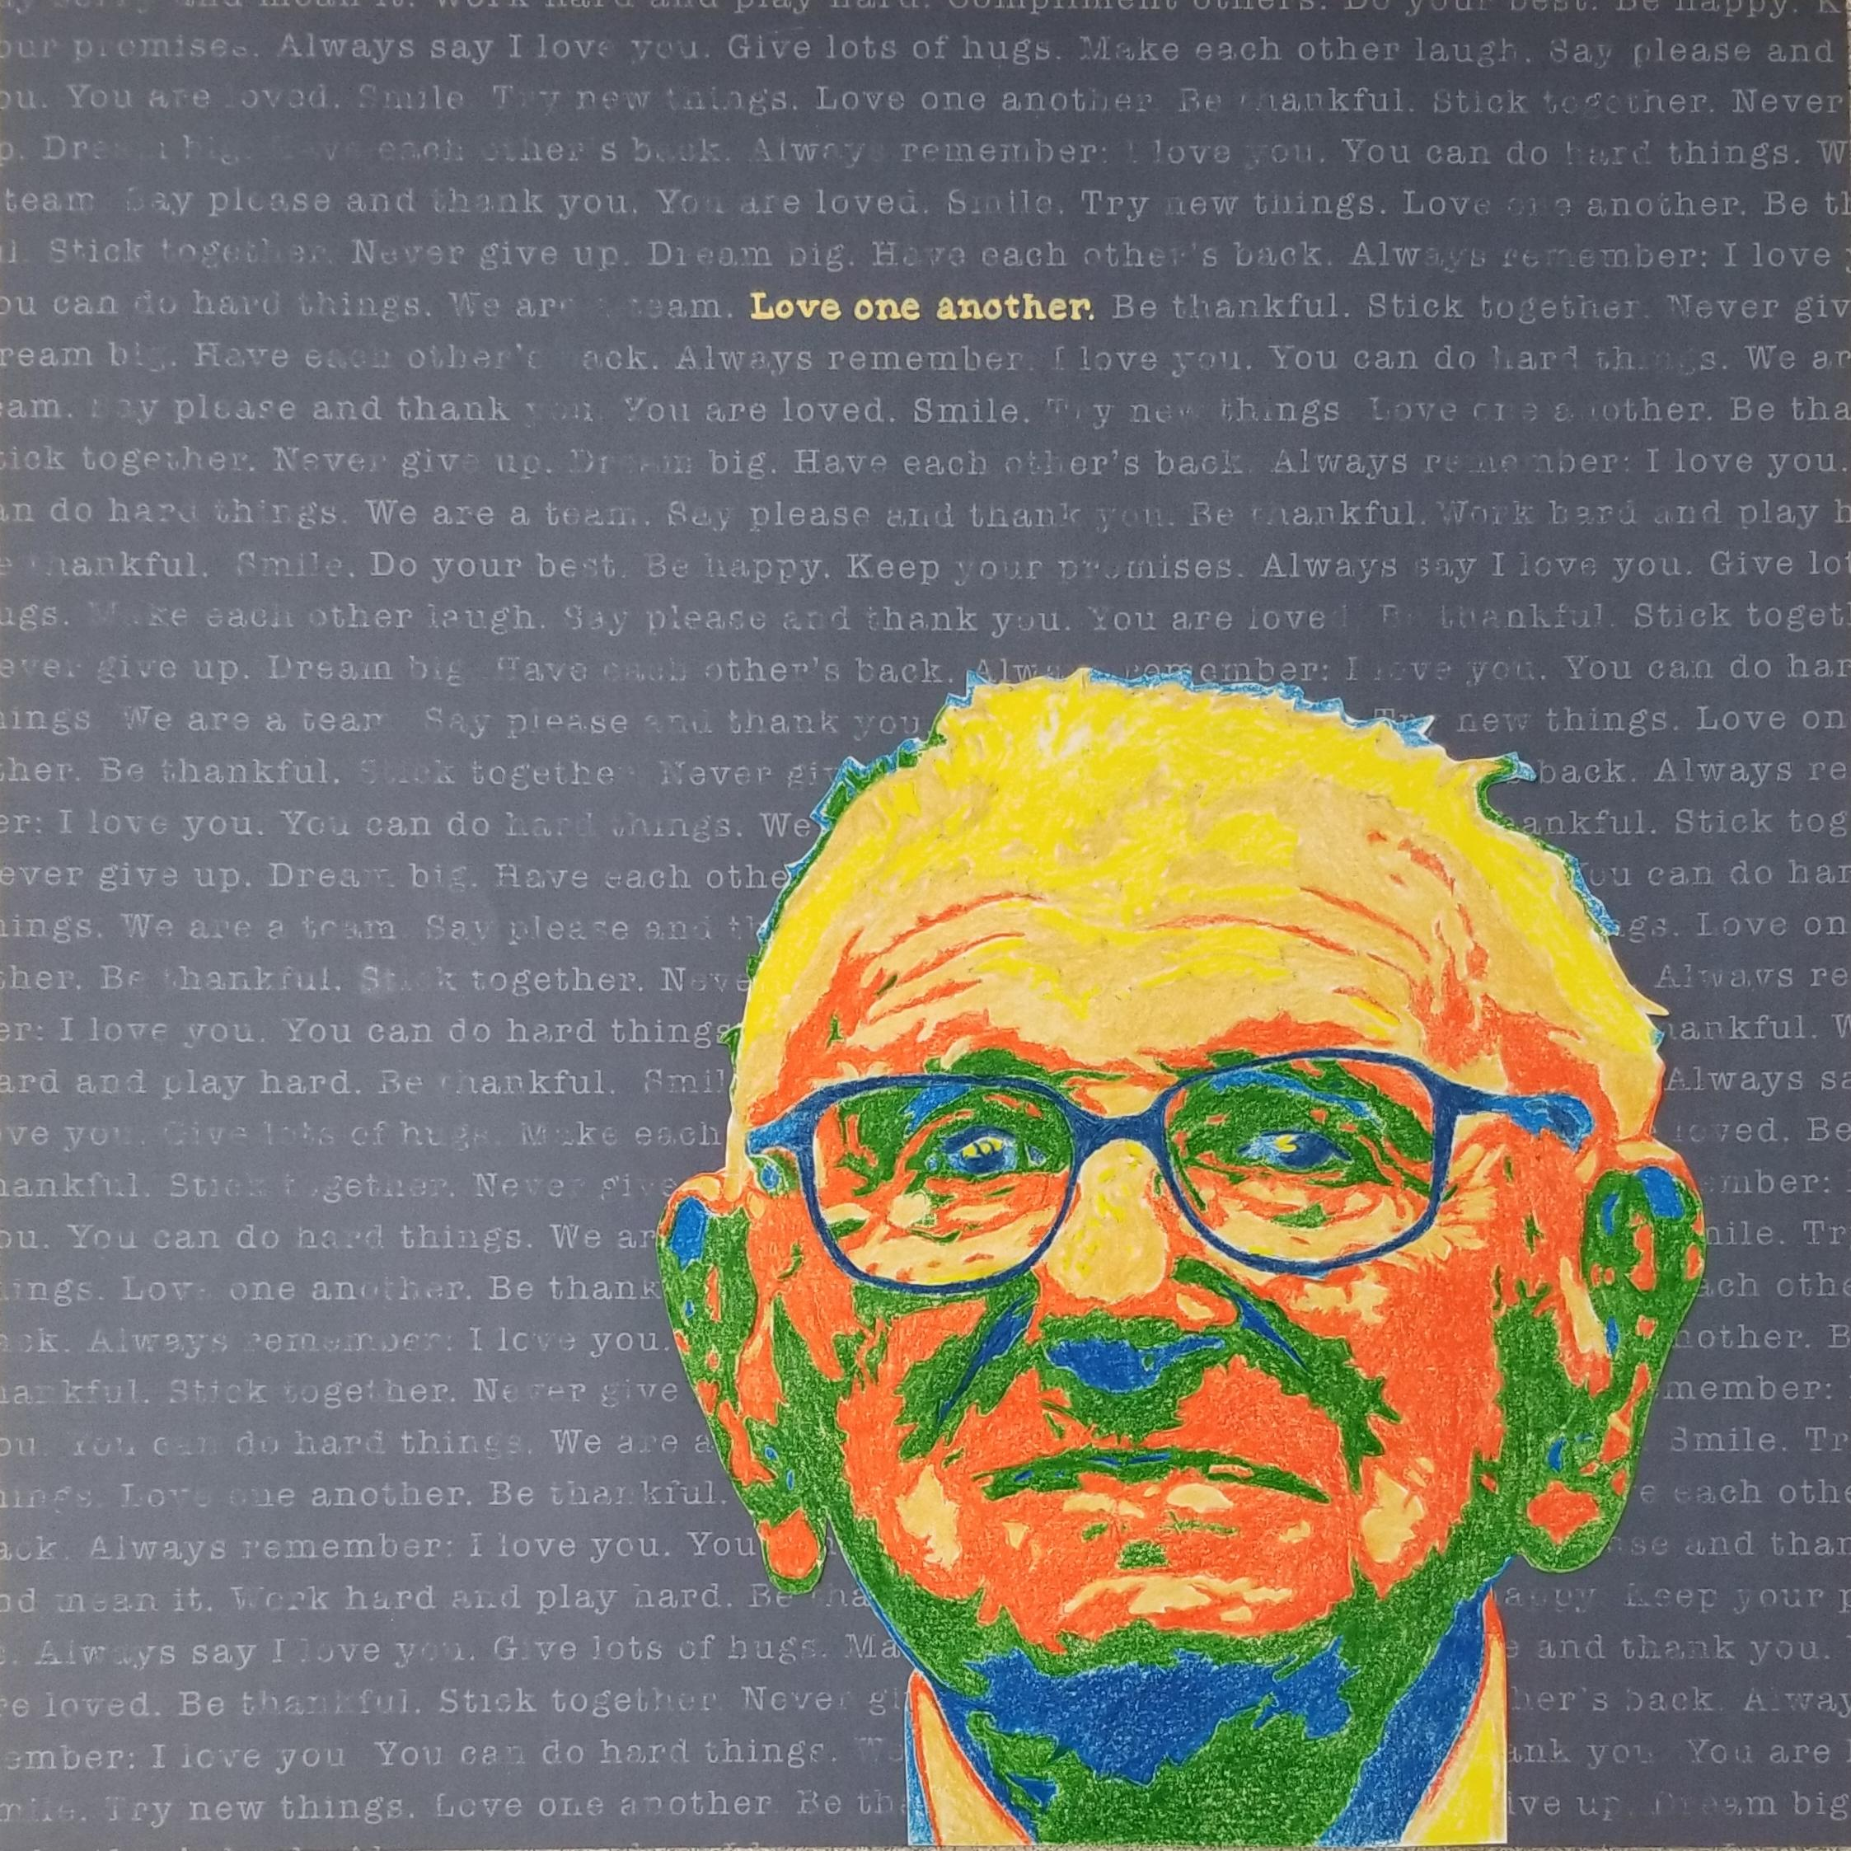
Central Focus/Lesson Summary: Students will practice applying varied values of shading by drawing a stylized portrait of someone from HIstory that they admire or look up to. Students will learn about the contemporary artist, Shepard Fairy, and his style of art. Students will create a Shepard Fairy inspired portrait using a posterized effect to create form using various color values.

Grades: 9-12

Big Idea: History : Game Changers/Historical Figures- people in history that changed the dynamic or made an impact, someone the student looks up to

Artist: Shepard Fairey
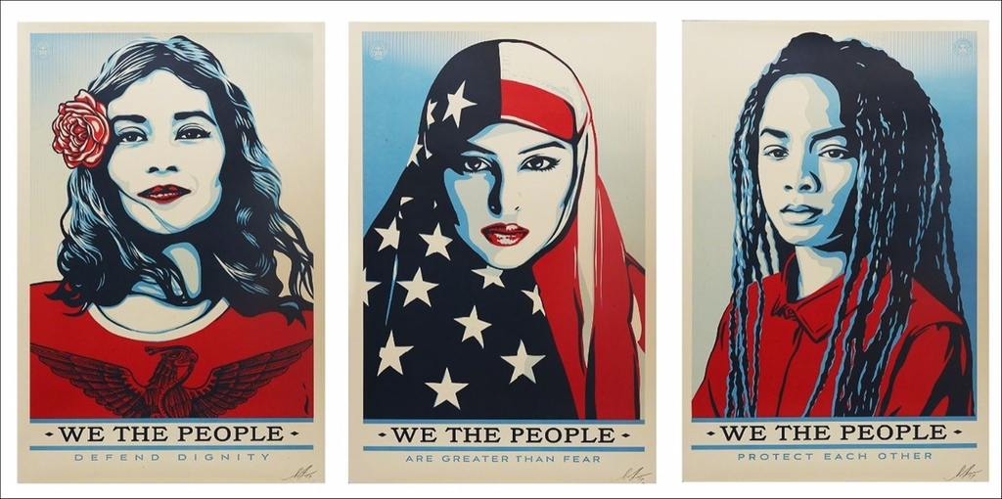

Objectives: Students will be able to...
- Study value of color in order to arrange color in a value scale (Day:1-2)
- Apply the concept of value to create a drawing with form (Day: 1-4)
- Identify the works of Shepard Fairey by analyzing his works and style. (Day: 1, 3)
- Compare and contrast photography and the realistic use of value compared to Shepard Fairey’s posterized graphic use of value (Day: 1)
Materials: 2D: Drawing
9x12 white vellum paper or 9”x9” white vellum paper with 1/4“ boarder, colored pencils, earasers, photograph, transfer paper or light box
Patterned Paper: Can be any color or pattern of the students’ choosing. The pattern paper will be provided.
Photo requirements: Clear, close-up photo, fits the page, has good contrast/not washed out or too dark
Posterizations: 5-7 values, multicolored
Color: consider value, hue, and intensity

Essential Questions:
- How do we commemorate those who have inspired others?
- Why is it important to address/remember those who do inspiring things?
- How do historical/important figures impact us today? (Thoughts and actions)
- How can society influence, impact, or inspire art/artists?

Standards:
National Standards:
- Anchor Standard 2: Organize and develop artistic ideas and work.
  - VA:Cr2.3.IIIa: Demonstrate in works of art or design how visual and material culture defines, shapes, enhances, inhibits, and/or empowers people's lives.
- Anchor Standard 6: Convey meaning through the presentation of artistic work.
  - VA:Pr6.1.IIa: Make, explain, and justify connections between artists or artwork and social, cultural, and political history.
- Anchor Standard 11: Relate artistic ideas and works with societal, cultural, and historical context to deepen understanding
  - VA:Cn11.1.Ia : Describe how knowledge of culture, traditions, and history may influence personal responses to art.
  - VA:Cn11.1.IIIa: Appraise the impact of an artist or a group of artists on the beliefs, values, and behaviors of a society.
NJ Visual Art Standards:
- 1.2 History of the Arts and Culture: All students will understand the role, development, and influence of the arts throughout history and across cultures. Strand A. History of the Arts and Culture
  - 1.2.12.A.1: Cultural and historical events impact art-making as well as how audiences respond to works of art.
- Standard 1.3 Performance: All students will synthesize those skills, media, methods, and technologies appropriate to creating, performing, and/or presenting works of art in dance, music, theatre, and visual art. Strand D. Visual Art
  - 1.3.12.D.1: Synthesize the elements of art and principles of design in an original portfolio of two- and three dimensional artworks that reflects personal style and a high degree of technical proficiency and expressivity

Modifications:
- The number of values used to posterize the image can be decreased to make the image less complicated for those who find it difficult/have an IEP/504. For those who have a higher skill level, the number of values can be increased so that the image is more challenging to draw/color.
- Directions can be written as a list or broken up into simple steps. The class can follow each step, so that everyone can follow at the same pace and receive help for each step (whole class or individuals).
- For ESL learners, the directions and slides can be translated into spanish. Individual worksheets/papers can be given that summarize the objectives for the day, the directions and any important information.

Assessments:
Day 1: Shepard Fairey- Image Discussion/Pre-Assessment
- Students will analyze the works of Shepard Fairey. They will discuss what they think his style is and what the intended meaning and purpose behind his works are. This will assess their prior knowledge of Shepard Fairey and their ability to identify the characteristics/style of his work.
Day 2: Entrance Slip Activity
- Students will receive an exit slip with 1 of the 2 essential questions on it. They will answer the questions anonymously. They will then crumple it up into a ball and either throw it into a basket or throw it across the room. Each student will get a piece of paper and read the answer aloud. The answers to the questions will be discussed and clarified. This will assess students' ability to relate the artmaking to context.
Day 3: PollEverywhere
- Students will participate in an online poll that assesses their knowledge of Shepard Fairey and their ability to identify his works as compared to works from similar artists in that genre. Students will see the responses in real time. The answer to the questions will be discussed.
Day 4: Portrait Description
- Students will write a brief description about their portrait. They will describe who the portrait is of, what they person did and why they inspired them. This will act as a mini artist statement. This will assess students’ ability to relate their artwork to the context of the assignment as well as their ability to use discourse/artist language.

Lesson Segment Summary
Day 1:
Introduction:
- To begin the lesson, students will be introduced to the artist, Shepard Fairey. They will briefly learn about his background as an artist and activist. They will then view the progression of his artistic career, including what inspired him and what his artwork is about. After viewing some of his works, students will be asked to identify key aspects of his style/art. This will then segway into the project.
- Students will be introduced to the assignment. We will discuss how they will create a posterized portrait of an inspiring figure, using Fairey’s style. They will select a photo of someone who inspires them, either from the 20th or 21st century. They must then select what colors they would like to use to create the value in the portrait.
Guided Instruction/Work Time:
- After they powerpoint is completed, students may begin finding a picture of someone who inspires them. The picture should be a clear portrait that is close enough to the subject to clearly see the facial features and other distinguishing features. A good portrait for this assignment would be using a photo from the tourso, up. After they find a photo, they will email it to Mrs. Stevens. She and I will use photoshop to put the photo into grayscale and posterize it. The student can pick whether to have the imahe posterized into 5-7 values. They should choose the number that shows the most amount of detail without being too complicated to draw.
Closing:
- Discussion on Shepard Fairey
- To wrap up the day, I will remind students of the requirements when looking for a photo. I will ask if students have any questions. Students will be dismissed.

Day 2:
Introduction:
- Students complete entrance slip activity
Guided Practice/Work Time:
- Students finish selecting a photo. The photo should be posterized in greyscale
- Students begin tracing photo. If they are waiting for a lightbox, they can start selecting colors and creating a value scale.
- Students either create value scale or work on tracing the photo on vellum paper.
Closing:
- Go over requirements, discuss what will happen the following class.
- Clean-up

Day 3:
Introduction:
- PollEverywhere questions: students use their laptop/phone to respond to questions online
Independent Work Time:
- Students work independently to continue tracing/transferring their image.
- They will finish picking colors and creating value scale. Some students may be finished transferring, they can work on coloring their portrait.
Closing/Clean-up:
- Discuss expectations for following class, answer any questions.
- Clean-up

Optional Workday:
- If students are behind or need additional time, they can have another independent work day.

Day 4:
Introduction:
- Discuss expectations/goals
  - Go over requirements
  - Finish coloring portrait
  - Cut out portrait
  - Paste on patterned paper
  - Write Portrait Description/Explanation
- Discuss Portrait Description
  - Who is it?
  - What did they do?
  - Why do they inspire you?
Guided Work Time:
- Students finish coloring their portrait. They will cut them out and paste on a patterned paper of their choice.
- Students will then write their Portrait Description. Either on a separate paper or on the back of their portrait.
Closure/Clean-up:
- Discuss what students will do if they aren’t finished. Answer any questions.
- Students hand in their artwork and description to the front desk.
- Clean-up

