NEW Material Artwork
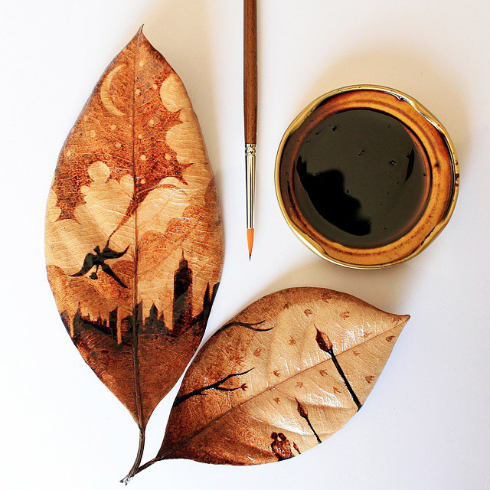
For this assignment, you will discover a NEW artmaking material. Your job will be to go around your house (indoors and outdoors) and find materials that could be used to create a “mark”. Meaning, you will find something that is not traditionally a drawing/painting material and turn it into one. Some examples: using coffee and tea as watercolor; using a wax candle as a drawing tool (like a crayon). Once you find your material(s), you will create a drawing or painting using that material.
Part One:
- Find a couple of different items that could be used as your medium. Think about things that make colorful juices or solid materials that leave a colorful mark when smeared.
  - You CANNOT use coffee and tea, as these are already popularly used materials. Be original! Discover something new!
- Experiment with your materials - figure out which one(s) you would like to use
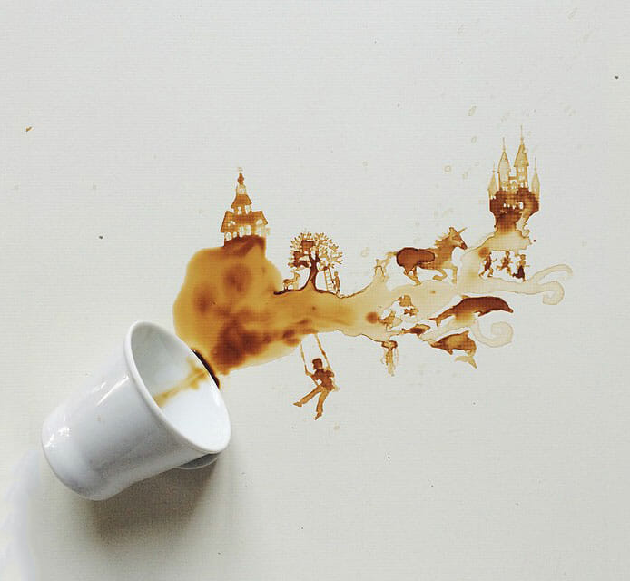
  - Try adding water to solid materials to see if you can turn it into a paint
  - Try smearing the material on paper
  - Collect juices and dilute them at different levels to create watercolors or paints - test it on paper
  - Try using your new material on different drawing/painting surfaces (paper, wood, cloth, etc)
- Determine the best way to use your materials

Part Two:
- Now that you have chosen your material and surface, begin brainstorming ideas of what you would like to create.
  - You can choose any subject matter you’d like. However, please think of a concept behind your work.
  - Size requirement - it must be at least 9x9 inches.
- Draw at least 2 sketches
- Create your final piece - please remember, your artwork should be fairly detailed and should have a concept behind it.

Due dates as listed below...

Due Dates
- Photos of chosen materials due the week of May 7th
- Photos of 2 sketches due the week of May 15th
- Progress photos uploaded the week of May 22nd
Projected Due: May 29th

**Due date subject to change**
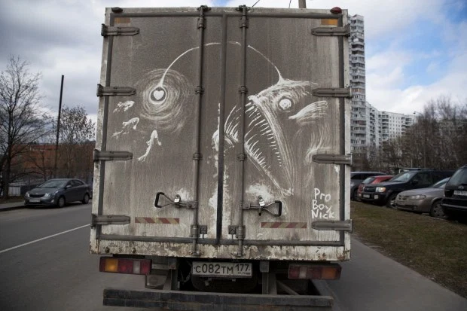
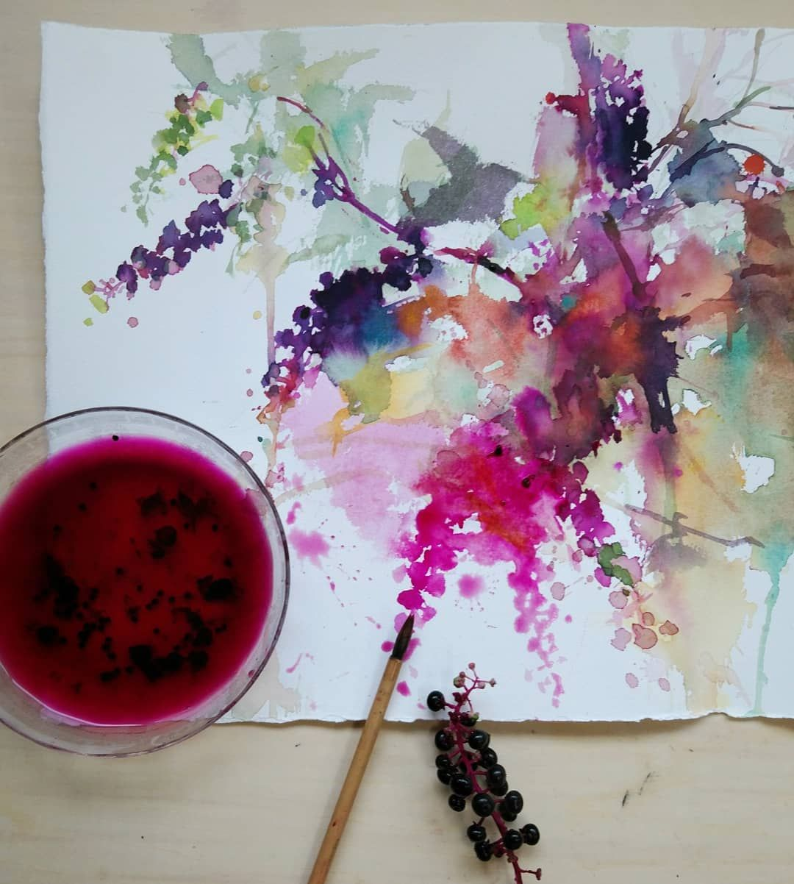
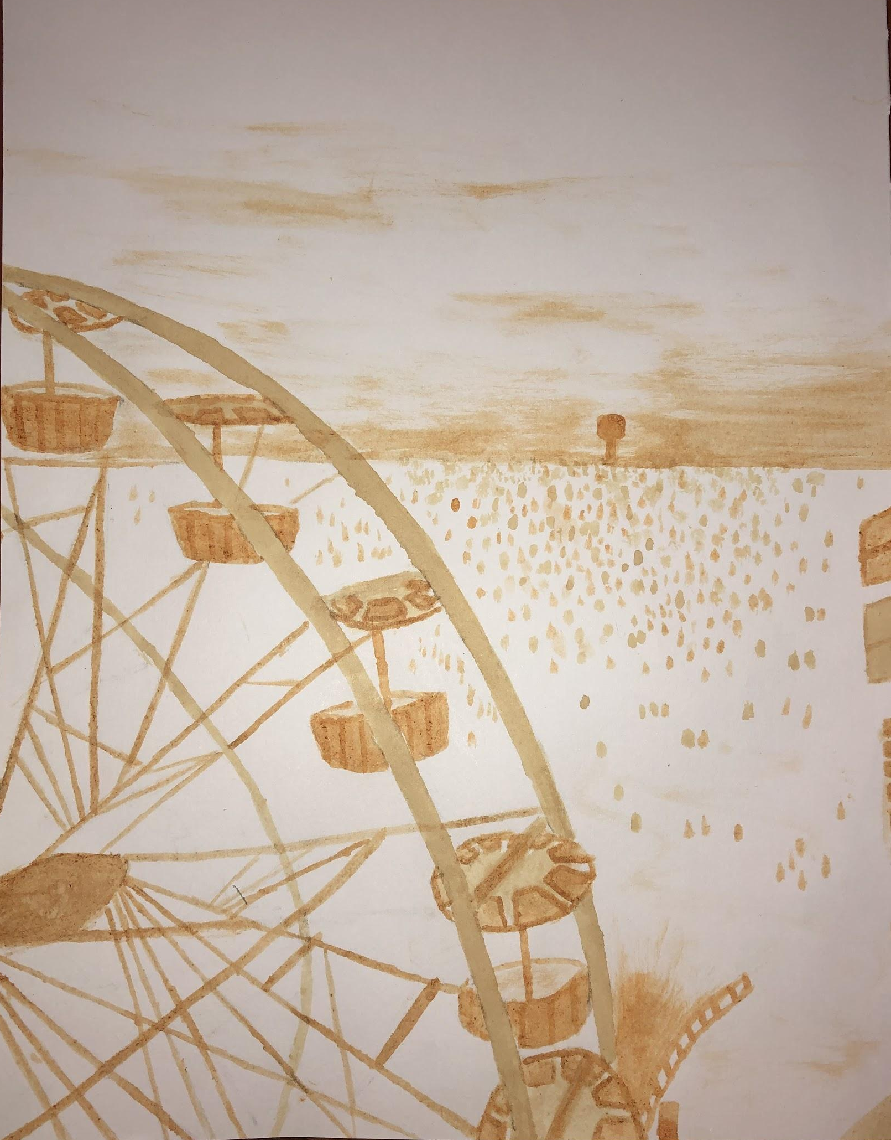
Student Examples
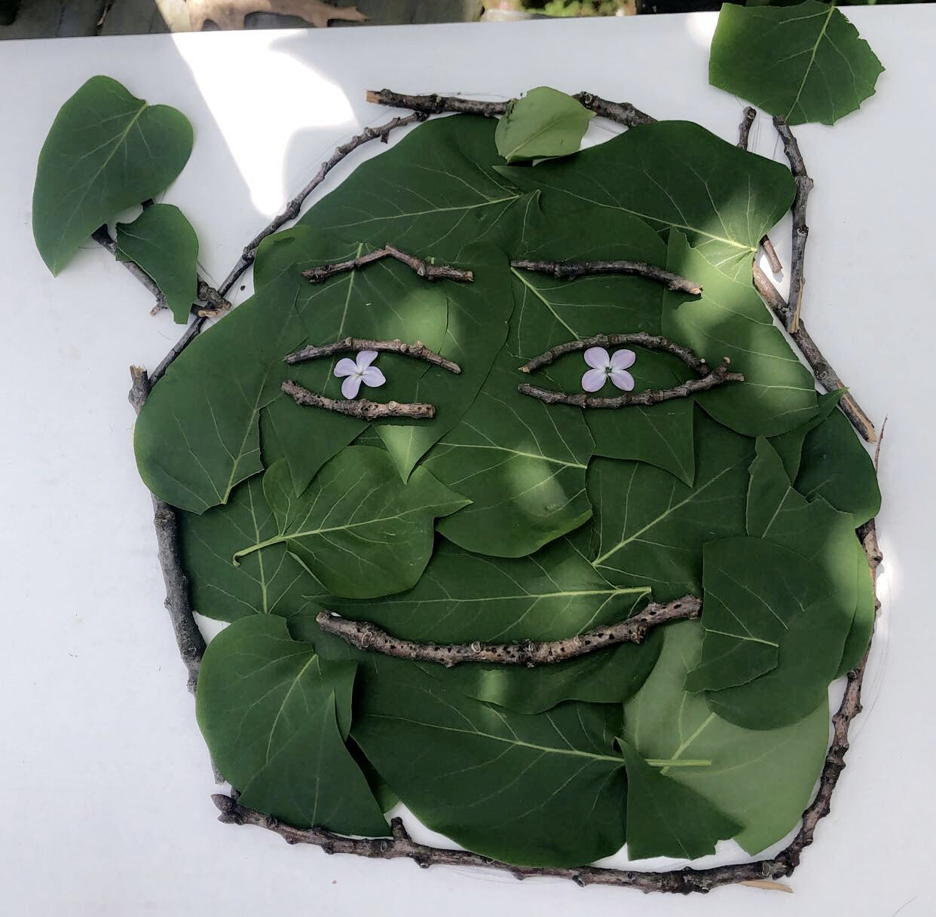

Leaves, sticks and flowers

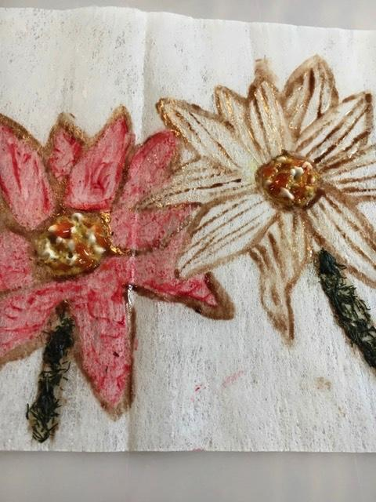

Tea and Paper
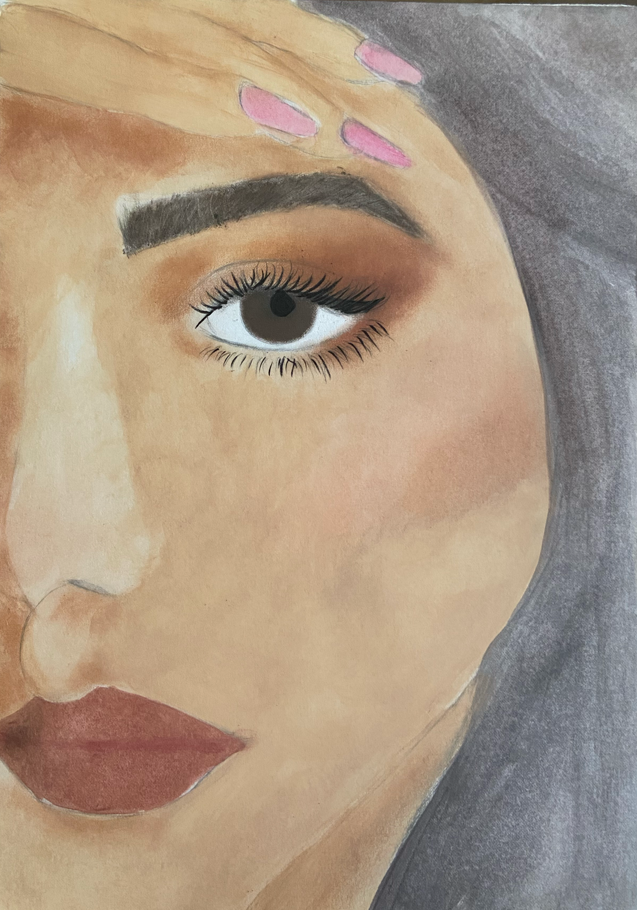
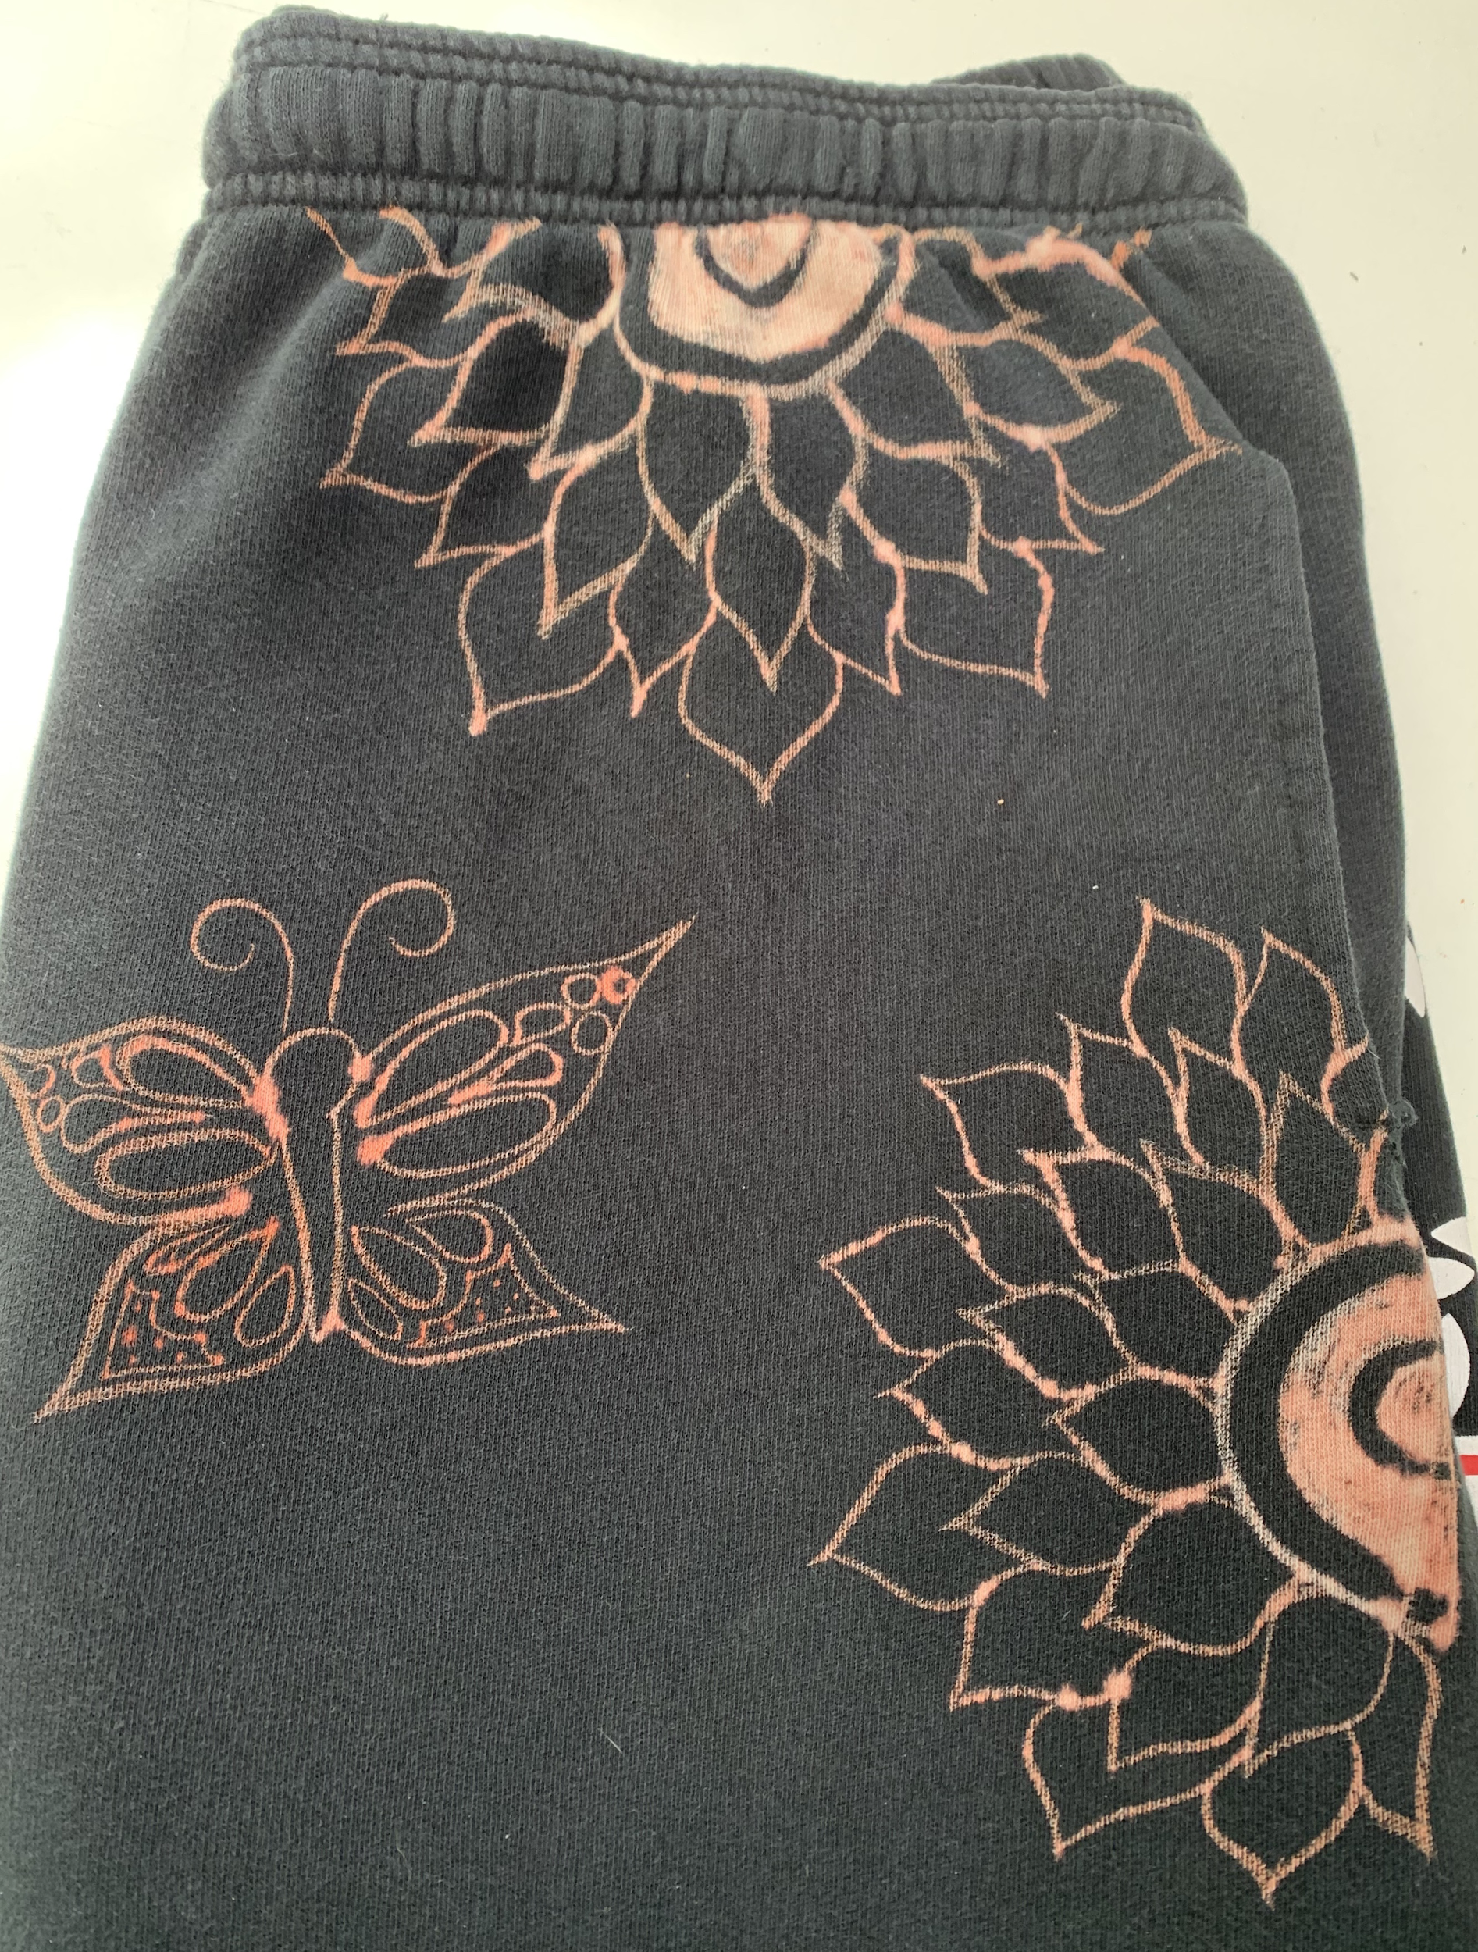
Makeup and paper Bleach and sweatpants Condaments and fabric sheet

