The Art of the Comic Book Lesson
Summary: Students will explore comics and how they portray aspects of fantasy and reality. Students will learn about how comics are made, how they are read and the different types of comics that exist. Students will practice using varied line weights as well as various pen and ink techniques in an effort to create form, texture, and value within their comic. They will develop their own comic that portrays a narrative exploring aspects of reality and fantasy. Students will analyze how comics can help us explore and understand everyday experiences.
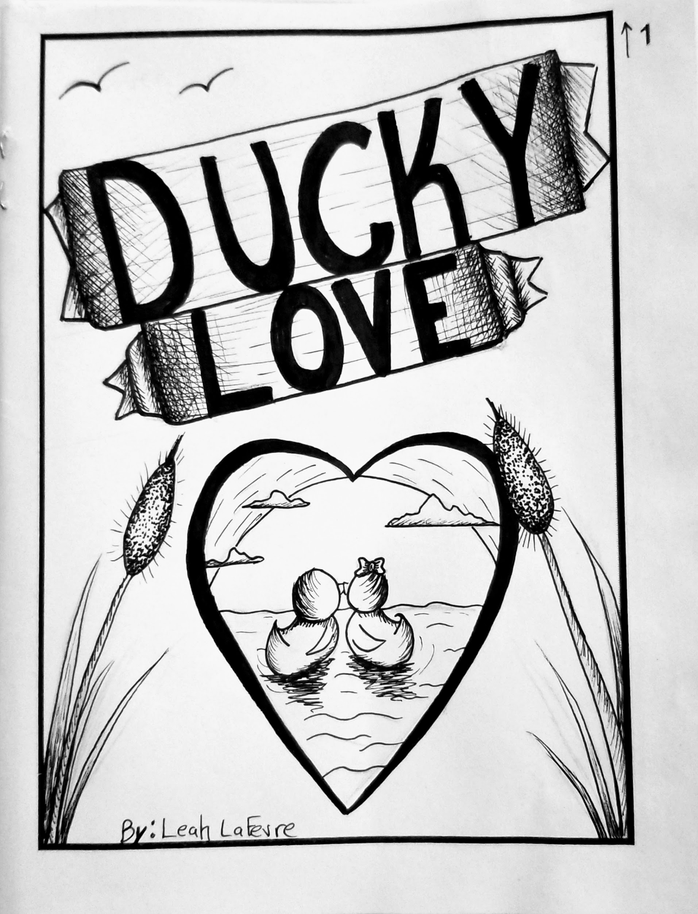
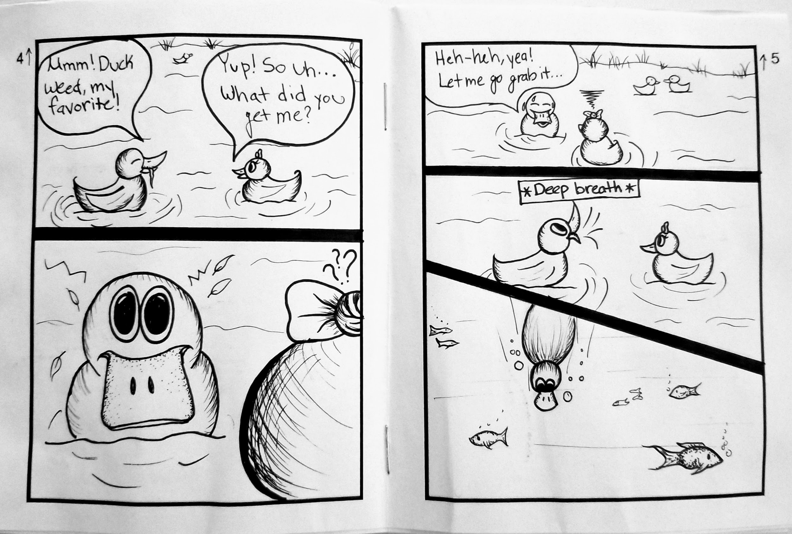
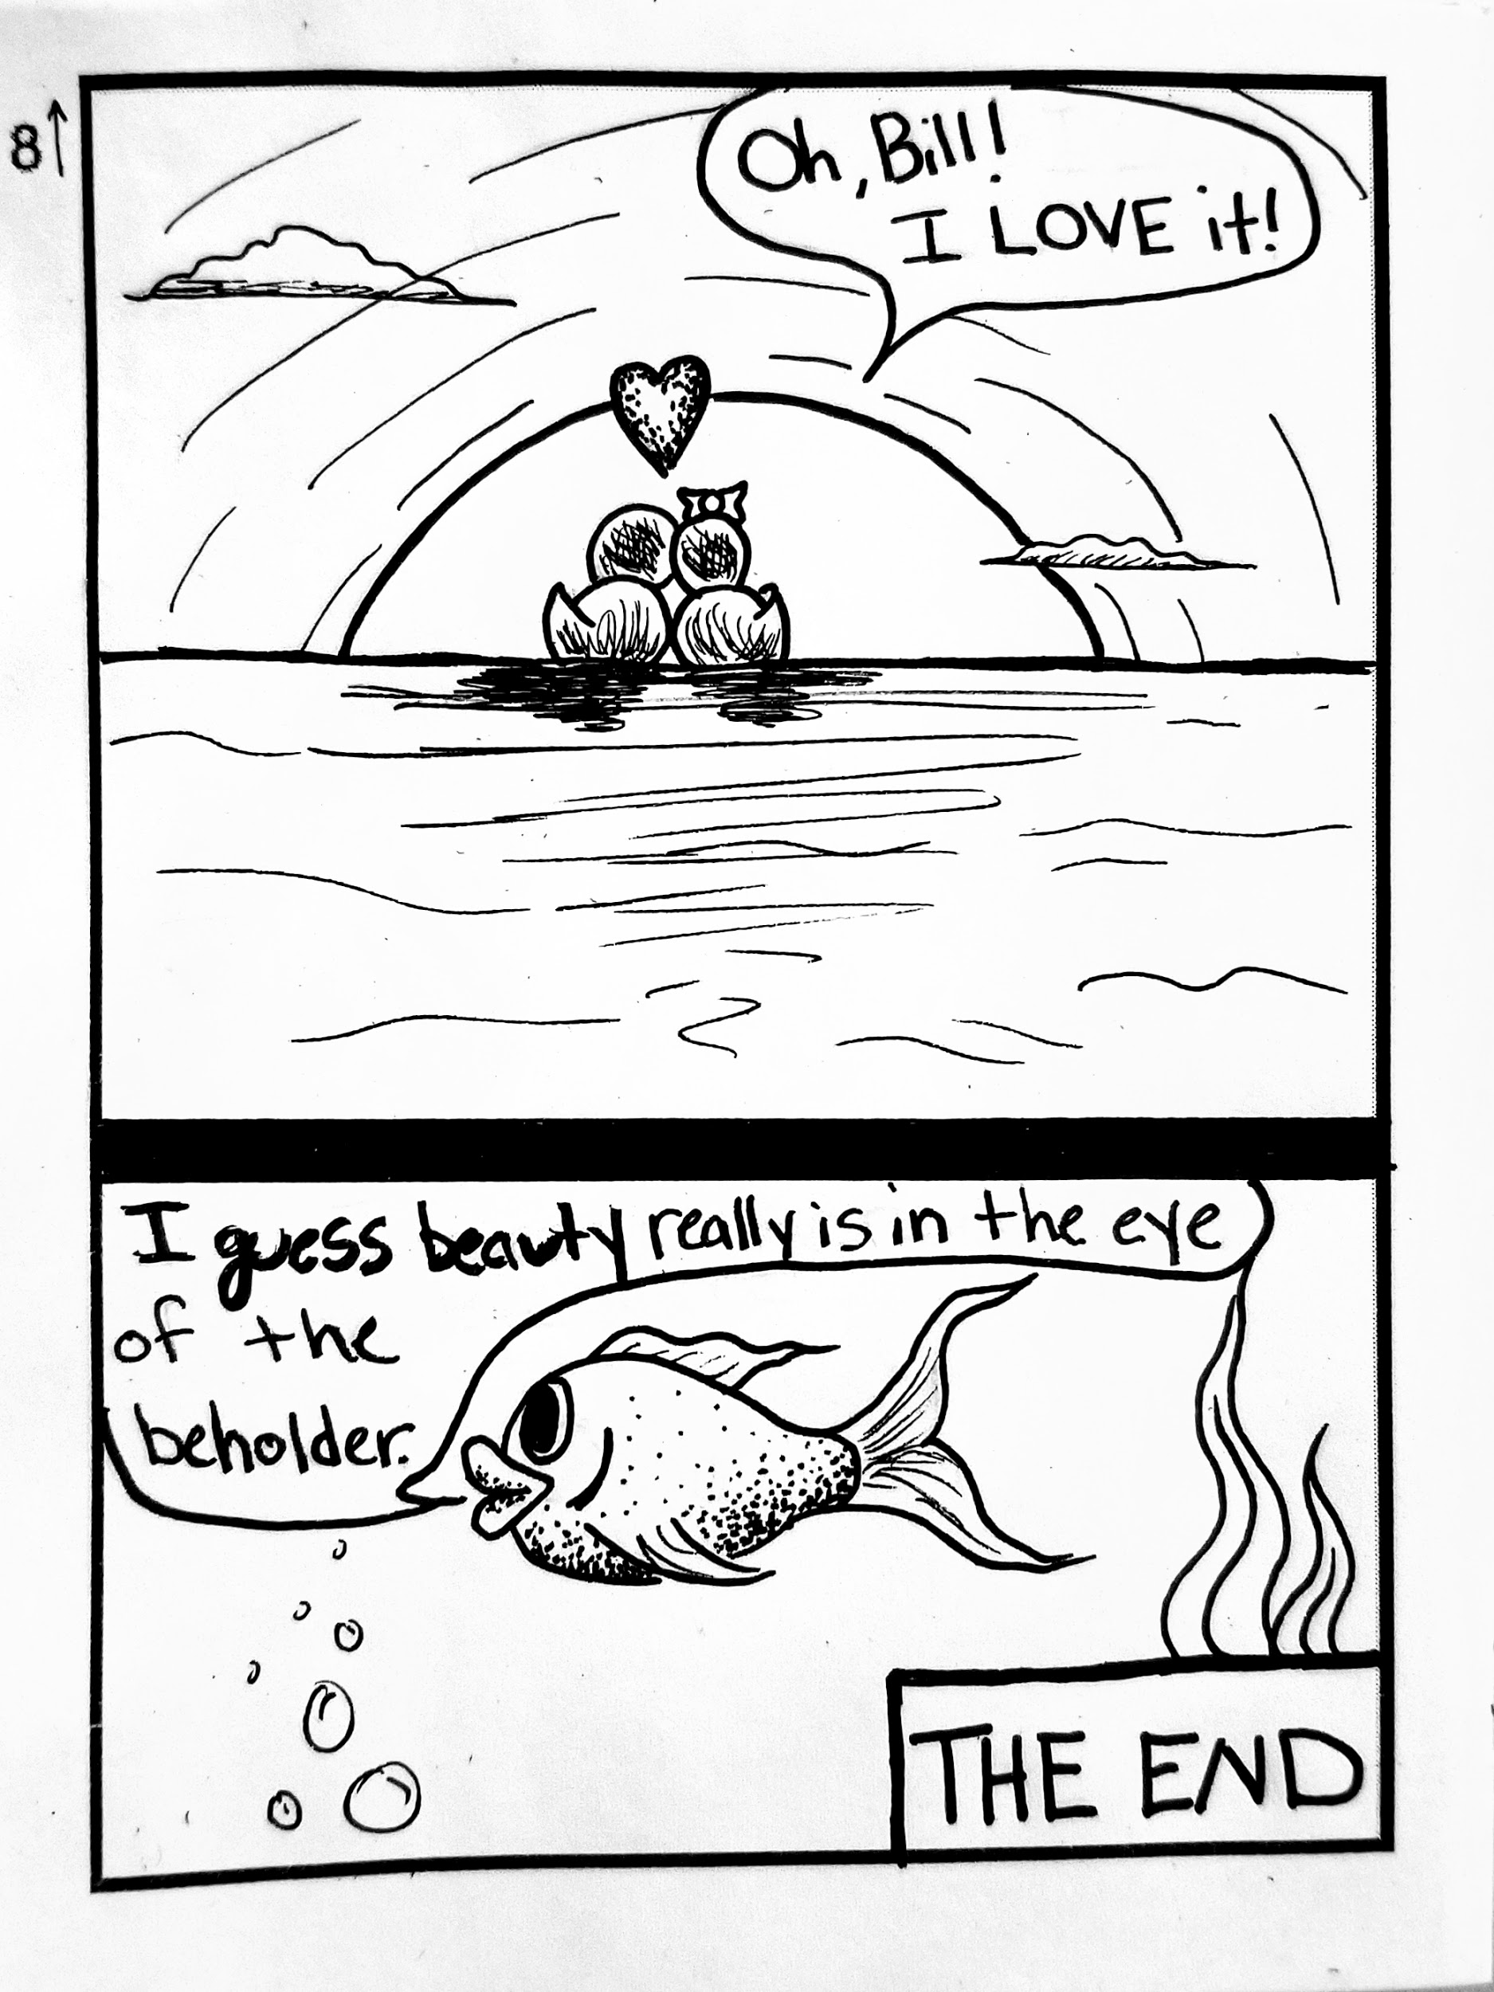
Big Idea: Reality vs. Fantasy
Artist/Artwork/Genre: Comics/illustration/cartoons & the “Chōjū-jinbutsu-giga” (12th-13th cent. Japanese manga comic) 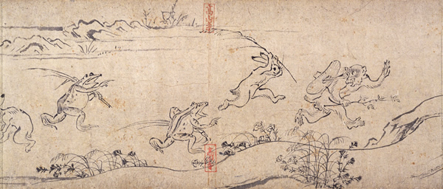

Materials: Pens (various sizes), 8”x11” white paper, pencils, watercolors (optional), ruler, scissors, newsprint (for drafts/sketches), glue (optional)

Objectives: Students will be able to…
- Create a short comic book by utilizing techniques of pen and ink as well as implementing comic book structure.
- Practice various pen and ink techniques by implementing hatching, cross-hatching, and stippling.
- Understand visual narrative by creating a sequence of images in their comic.
- Compare and contrast fantasy and reality by identifying and applying aspects of each.

Standards:
NJ Visual Art
- Standard 1.1 The Creative Process: All students will demonstrate an understanding of the elements and principles that govern the creation of works of art in dance, music, theatre, and visual art. Strand D. Visual Art
  - 1.1.12.D.2: Translate literary, musical, theatrical, and dance compositions by using them as stimulus/inspiration for corresponding visual artworks.
  - 1.1.12.D.1 Distinguish innovative applications of the elements of art and principles of design in visual artworks from diverse cultural perspectives and identify specific cross-cultural themes.
- Standard 1.3 Performance: All students will synthesize those skills, media, methods, and technologies appropriate to creating, performing, and/or presenting works of art in dance, music, theatre, and visual art. Strand D. Visual Art
  - 1.3.12.D.5 Identify the styles and artistic processes used in the creation of culturally and historically diverse two and three-dimensional artworks, and emulate those styles by creating an original body of work.
National Visual Art
- Anchor Standard 7: Perceive and analyze artistic work
  - VA:Re.7.1.Ia: Hypothesize ways in which art influences perception and understanding of human experiences.

Essential Questions:
- How do people “escape” reality?
- How can exploring fantasy help us understand experiences in reality?

Key Questions:
- How can comics help us make sense of the world?
- What types of comics are there?
- How are comics cross-cultural?

Accommodations/Modifications:
- If a student struggles with drawing characters, they can create a fumetti (comic made from photographs). They can find images online or use images from home.
- If a student struggles with writing, they can type their narrative, print it out, and paste it on each page. The same can be done for the title. They can either cut and paste the text or they can use a lightbox/tracing paper to transfer the text.
- ESL Students: They may create their comic in their own language, but should write a synopsis of the story in English so that others can understand the story.
Vocabulary:
- Comic
- Manga
- Panel
- Gutter

Assessments:
- Pre Assessment: Pen and Ink Worksheet - Students complete a worksheet to assess their ability to apply stippling, cross-hatching, and hatching in different values.
- Image Analysis: On day 2, students begin by analyzing various comics. They are asked to define what a comic is, using comic examples to support their answer. This can also be used as a pre-assessment.
- Discussion on Chōjū-jinbutsu-giga: Day 2, students discuss and analyze the scroll “Chōjū-jinbutsu-giga”. They will be asked to identify aspects of reality and fantasy. They then will be asked to analyze the image for the possible narrative/meaning behind it.
- Kahoot!: On day 3, students will use their phones and Chromebooks to complete a series of questions on kahoot. These questions will relate to the various terms, styles, and techniques used to create comics.
- Pass it on Doodle Game: On day 4, students will participate in a game where they have to create a caption and/or doodle. This assesses their ability to create a caption to an image and an image to a caption. As this is how comics are created. The image and caption need to relate to one another in order for the reader to understand what is happening in the narrative.
- Possible Gallery Walk and Peer feedback: Last day of the project. Students walk around the room and read another student’s comic. They then provide feedback.
- Rubric

Lesson Segment Breakdown
Day 1:
- Introduction: students will be introduced to medium(s) of pen and ink. They will explore the different techniques used when creating pen and ink drawings.
- Work time:
  - Pre-assessment: Students will complete a worksheet where they will apply the techniques of stippling, hatching, and cross-hatching to make a 2D drawing 3D.
- If time permits, students will be introduced to the topic of comics.
- Closing
Day 2:
- Introduction: Students will be introduced to “comics”. They will explore the styles and origins of comics. They will learn how comics are read and how they are made (the components of a comic). They will explore how comics combine aspects of fantasy and reality and human experience. They will analyze the “Chōjū-jinbutsu-giga” ( ancient Japanese Manga). Students will be introduced to the project.
- Work Time: students will begin brainstorming ideas. They must select a story/narrative they want to tell. This can be based on an experience they had or they can make up one. If their narrative is mostly fantasy, it should have an underlying meaning that relates to real-life experiences (like a life lesson). They then fill out the Storyboard Template. They should sketch their ideas on this before moving to the final paper.
- Closing
Day 3:
- Opening activity: Kahoot!
  - Students will answer a series of questions about comics to assess their comprehension thus far.
- Work Time: Students continue to brainstorm their narrative. Once they have chosen it, they should write it as a brief story. They will continue to sketch on their storyboard template. Once they finish, they can begin working on their final paper.
- Closing
Day 4-7: Independent Work Days
- Opening Activities: Kahoot and Doodle Game
- Day 4: Opening activity: Doodle Game
  - Students are given a prompt and have to draw a small doodle of it. They then pass their doodle off to someone who doesn’t know the prompt. They then have to write a caption to the image in hopes that it relates to the prompt. This helps students practice relating images to context. As the premise of comics is visual narrative.
- Day 5-7: Kahoot games/discussion questions (the students really enjoy kahoot)
- Work Time: Students finish their storyboard and work on their final paper. The final paper should first be done in pencil. Once the panel/page/book is drawn in pencil, they will use pen and ink to trace overtop. They will then erase any remaining pencil marks. Whiteout will be available to fix mistakes.
- Closing
Day 8:
- Half of class: possible work time
- Other half of class: Gallery Walk
  - Students walk around the room and look at classmate’s comics. They then choose one to read and peer review.

